MOHAMMAD ISRARUL PHARMACIST 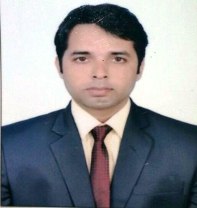 Mob.No.9967282759
E-Mail: israrul.siddiqui@gmail.com
Location,Mumbai.INDIA

PERSONAL SUMMARY
A Motivated Pharmacist with a Real Passion For Healthcare and The Ability To Develop and Growth a Pharmacy Business. Able To Advise Patients on Medication Brands, Medication storage, Medication Equipment and Health-care Supplies.
Currently looking For a Suitable Pharmacist vacancy in a Modern Well Equipped Pharmacy.

WORK EXPERIENCE
- Doing Work in National Medical in (Siwree hospital) From3rd OCT 2013 to till date…...
- MORDEN MEDICAL worked as pharmacist in10 MARCH 2012 TO 16 APRIL 2013.
- Responsible for the day to day Running of the Pharmacy, Providing a Sympathetic and supportive service To Patients and Identifying The Right Healthcare solution To Meet Their Needs.
DUTIES
- Accurately Dispensing Drugs To Patients According To The Doctor Prescription.
- Instruction Patients on How To Use Medication, Possible Side Effects and Storage.
- Answering questioning From Patients and Staff about medicine.
- Maintaining Pharmaceutical Stock ordering more drugs.

KEY SKILLS
- Keeping up to date with Developments in The pharmaceutical Industry .
- Understanding of Various Drugs and How They react in Humans and with each other.
- Extensive Knowledge of complex Medical terms and Procedures.
- Good Time Management and organization skills.
- Familiar With Major computer Applications Like MSWORD, Excel, and the internet.
- Co-Curricular activity:
- Four week industrial training in Uttar Pradesh drug and Pharmaceuticals Co. ltd. Lucknow. India
- Attend seminar on the Indian Hospital Pharmacy Association 4th National Convention 2005 Lucknow (India).
EDUCATIONAL QUALIFICATION

- B.PHARM from Integral University Lucknow in the year 2009.
- Intermediate From Khair Inter College Basti in the year2004.
- High school From S.R.N.C.K.V.M. Inter College SANT KABIR NAGAR in the year2001.

Languages known : Urdu, English, Hindi.
Hobbies : Playing Cricket, Reading Newspapers.
Father’s Name : Mohd Shoab Siddiqui.
Date of Birth : July. 20, 1987
DECLARATION | I consider myself familiar with pharmacy aspects. I am also confident of my ability to work in a team.  I hereby declare that the information furnished above is true to the best of my knowledge.

Date: 10/10/16 (MOHAMMAD ISRARUL)
PLACE.MUMBAI(INDIA)

